TECHNICAL DESIGN DOCUMENT
AI Co-Pilot
Persona-Aware Operational Intelligence for the RAD-OPS
Mobile Diagnostic Logistics Platform
Field | Value
Document ID | RAD-OPS-TDD-001
Version | 0.2 (Draft — adds Project Definition & Value Case)
Date | July 7, 2026
Status | DRAFT — pending SA and stakeholder sign-off
Prepared by | Kenneth Rubio
Reviewers | Solution Architect · Security Lead · Delivery Lead
Downstream artifacts | Statement of Work (SOW) · Functional Requirements Document (FRD)
Source baseline | AI_COPILOT_ARCHITECTURE.md

Contents
Contents 2
1. Purpose & How to Use This Document 3
2. Executive Summary 3
3. Project Definition & Value Case 3
3.1 Definition & Problem 3
3.2 How Value Is Created 4
3.3 Expected Outcomes at Completion 4
3.4 Increased Efficiencies 5
3.5 ROI Model 6
4. Scope 7
4.1 In Scope (v1) 7
4.2 Out of Scope (v1) — documented extension points 7
5. Solution Overview — Personas 8
6. Solution Architecture 9
6.1 Technology Stack 9
6.2 Defining Design Decisions 10
7. Component Design 11
7.1 Frontend — Co-Pilot Workspace 11
7.2 Backend — Route Handlers 11
7.3 System Prompt Assembly (prompts.ts) 11
8. Data Flow 13
9. Data Design & Persistence 14
10. Security & Compliance Posture 15
11. Non-Functional Requirements (NFR Register) 16
12. Functional Requirements (FRD-Ready Register) 17
13. Assumptions, Dependencies & Risks 19
13.1 Assumptions (carry into SOW) 19
13.2 Risks 19
14. Delivery Plan & Work Packages (SOW-Ready) 20
15. Acceptance Criteria (SOW-Ready) 20
16. Environments & Configuration 21
17. Open Questions for Solution Architect Review 21
18. Glossary 22

1. Purpose & How to Use This Document
This Technical Design Document (TDD) formalizes the design of the AI Co-Pilot subsystem so that (a) the Solution Architect can validate, challenge, and sign off on the design; (b) commercial teams can lift the scope, work packages, and acceptance criteria directly into a Statement of Work; and (c) the functional requirements register in Section 12 can be extracted verbatim into a Functional Requirements Document.
Downstream artifact | Source sections in this TDD | What to lift
Business case | §3 Project Definition & Value Case | Definition, expected outcomes, efficiency levers, driver-based ROI model
SOW | §4 Scope · §14 Delivery Plan · §15 Acceptance | In/out-of-scope lists, work packages WP1–WP6, milestones, deliverables, acceptance criteria, assumptions
FRD | §12 Functional Requirements · §11 NFRs | FR-xxx and NFR-xxx registers with traceability IDs, priorities, and verification methods
SA review | §6–§10 Design · §13 Risks · §17 Open Questions | Architecture decisions, data model, security posture, decision log, open questions

2. Executive Summary
The AI Co-Pilot is an embedded, persona-aware AI assistant for the RAD-OPS mobile diagnostic logistics platform. It is not a generic chatbot: every request is grounded in a real-time snapshot of live operational data — orders, technicians, specimens, and invoices — pulled from the database at request time. The subsystem ships as a dedicated 'copilot' role with three specialized personas: Dispatcher (Smart Fleet Orchestrator), Billing (Revenue Cycle Guard), and Field-Tech (Field Operations Assistant).
The design's defining principle is two independent context channels: a compact text snapshot feeds the language model, while a separate live updating React rail feeds the human operator. They intentionally share no code. Responses are grounded-only — the system prompt forbids asserting any operational fact absent from the injected context and forbids inventing PHI.

3. Project Definition & Value Case

3.1 Definition & Problem
The AI Co-Pilot is an embedded, persona-aware AI assistant that reasons over the RAD-OPS platform's live operational state — orders, technicians, specimens, and invoices — and proposes concrete next steps. It is delivered as a dedicated role within RAD-OPS, exposing three specialized operational modules (Dispatcher, Billing, Field-Tech) over one shared, grounded engine, with healthcare-grade guardrails built into the architecture rather than bolted on as policy.
Problem it solves
Operational staff hold critical decisions in their heads under time pressure: which technician covers a STAT order before a specimen expires, whether a claim will be denied before it is submitted, what the next chain-of-custody step is. The Co-Pilot puts a grounded, always-available advisor next to those decisions — without the hallucination and data-exposure risks that make generic AI a non-starter in a healthcare setting.

3.2 How Value Is Created
Value flows in a chain: each persona capability drives an efficiency lever, and each lever produces a business outcome. Every lever below traces to a capability specified in this document (see §5 Personas and §7 Component Design); the magnitude of each outcome depends on the client's operational baseline, captured in the ROI model in §3.5.
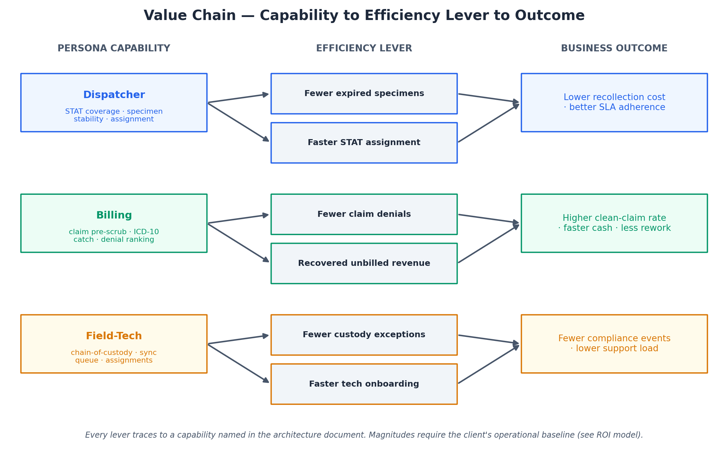
Figure 1 — From persona capability to efficiency lever to business outcome

3.3 Expected Outcomes at Completion
On completion of v1, RAD-OPS gains the following. These are qualitative statements grounded in the delivered functionality; quantified targets belong to the ROI model once baselined.
Outcome | What it means operationally
Faster, better-informed dispatch | Dispatchers reason about STAT coverage and specimen expiry with a live advisor, reducing time-to-assign and specimens lost to expiry.
Cleaner claims, fewer denials | Billing catches missing ICD-10 codes and denial risks before submission and surfaces unbilled revenue sitting in the queue.
More consistent field execution | Technicians get on-demand chain-of-custody guidance and assignment clarity, reducing compliance exceptions and support escalations.
Trustworthy AI in a regulated setting | Grounded-only responses and PHI guardrails make AI assistance defensible to compliance and security stakeholders.
Operational resilience | Server-side persistence guarantees no lost conversations; honest error surfacing keeps operators informed during vendor issues.
Low-friction rollout | Mock mode allows demonstration and phased adoption; the persona model lets the client start with one module and expand.

3.4 Increased Efficiencies
Each efficiency lever is expressed as the operational mechanism (grounded in this design) and the metric it moves (to be measured against the client baseline).

Dispatcher — Smart Fleet Orchestrator
Mechanism (grounded) | Metric it moves
Live specimen-stability windows (minutes-to-expiry) surfaced during assignment | Specimens lost to expiry → avoided recollection cost and repeat visits
STAT coverage reasoning over the live roster | Time-to-assign for STAT orders; SLA adherence
Density-vs-priority guidance | Route efficiency; dispatcher cognitive load and decision time

Billing — Revenue Cycle Guard
Mechanism (grounded) | Metric it moves
Pre-scrub of claims and detection of missing ICD-10 codes before submission | First-pass (clean-claim) rate; denial rate
Denial-risk ranking of invoices | Rework hours on rejected claims; days-in-AR
Surfacing open (unbilled) revenue total | Revenue leakage recovered from the unbilled queue

Field-Tech — Field Operations Assistant
Mechanism (grounded) | Metric it moves
On-demand chain-of-custody step guidance | Custody/compliance exceptions per period
Active-assignment and sync-queue answers in the field | Support calls to dispatch; time lost to uncertainty
Self-service operational guidance | New-technician time-to-productivity

3.5 ROI Model

Benefit drivers
Driver | Formula | Inputs from client
Recollections avoided | expired specimens/yr × reduction % × cost per recollection | expiry volume, cost per recollection
Denials avoided | claims/yr × denial rate × reduction % × cost per denial | claim volume, denial rate, rework cost
Unbilled revenue recovered | unbilled backlog × recovery % × margin | unbilled total, recovery uplift
Labor time saved | (dispatch + billing + field hrs/wk) × 52 × loaded rate | hours saved, loaded rate

Illustrative worked example
Illustrative inputs (amber) — replace with client actuals:
Input | Placeholder | Illustrative
Expired specimens per year | [ ___ ] | 1,200
Reduction in expiries with Co-Pilot | [ __% ] | 20%
Cost per recollection (courier + lab + revisit) | [ $__ ] | $85
Claims per year | [ ___ ] | 80,000
Current denial rate | [ __% ] | 8%
Denials avoided (of denied claims) | [ __% ] | 15%
Cost per denied claim (rework + delay) | [ $__ ] | $25
Staff hours saved per week (all personas) | [ ___ ] | 40
Loaded hourly rate | [ $__ ] | $45
Illustrative benefit (arithmetic on the illustrative inputs above only):
Driver | Illustrative annual benefit
Recollections avoided (1,200 × 20% × $85) | $20,400
Denials avoided (80,000 × 8% × 15% × $25) | $24,000
Labor time saved (40 × 52 × $45) | $93,600
Illustrative gross annual benefit (excl. unbilled recovery) | $138,000
ROI % = (annual benefit − annual cost) ÷ annual cost. Payback (months) = implementation cost ÷ (annual benefit ÷ 12). Annual cost combines the SOW implementation fee ([from SOW]) plus running costs — Anthropic API usage, Vercel, and Supabase ([client-borne]). To convert this framework into a committed business case, gather baseline volumes, unit costs, and current time-on-task, and agree a measurement window; these are tracked as Open Question Q1 and Q4 in §17.

4. Scope

4.1 In Scope (v1)
- Three personas (dispatcher, billing, field-tech) with per-persona mission prompts, live-context branches, and UI presets
- Full-screen 3-column Co-Pilot workspace at /copilot with responsive mobile behavior
- Token-by-token streaming chat via Vercel AI SDK (streamText → UI message stream → useChat)
- Live operational context builder (context.ts) reading orders, technicians, specimens, invoices, sync queue
- Server-side conversation persistence (one conversation per user per persona) with race-safe get-or-create
- JWT session auth with role gate (copilot + admin), mirroring the existing proxy.ts pattern
- STAT priority toggle injecting an additional dispatcher directive
- Graceful mock mode when Supabase is unconfigured (chat streams, unpersisted)
- Real provider error surfacing to the UI

4.2 Out of Scope (v1) — documented extension points
- Tool calling / write actions (assign order, reconcile invoice) — model currently recommends, never executes
- Voice dictation for field-tech (Web Speech) — flagged post-v1 stretch goal
- Additional personas beyond the three shipped
- Multi-conversation history per persona (v1 enforces one thread per user per persona)
- Supabase Auth / RLS-policy-based access (v1 deliberately uses application-layer gating only)

5. Solution Overview — Personas
The Co-Pilot exposes three operational modules over one shared engine. Each persona is the combination of a mission directive (prompts.ts), a tailored live-context branch (context.ts), and a client-safe UI preset (personas.ts, deliberately separated so no React or icon imports leak into the Node route handler).
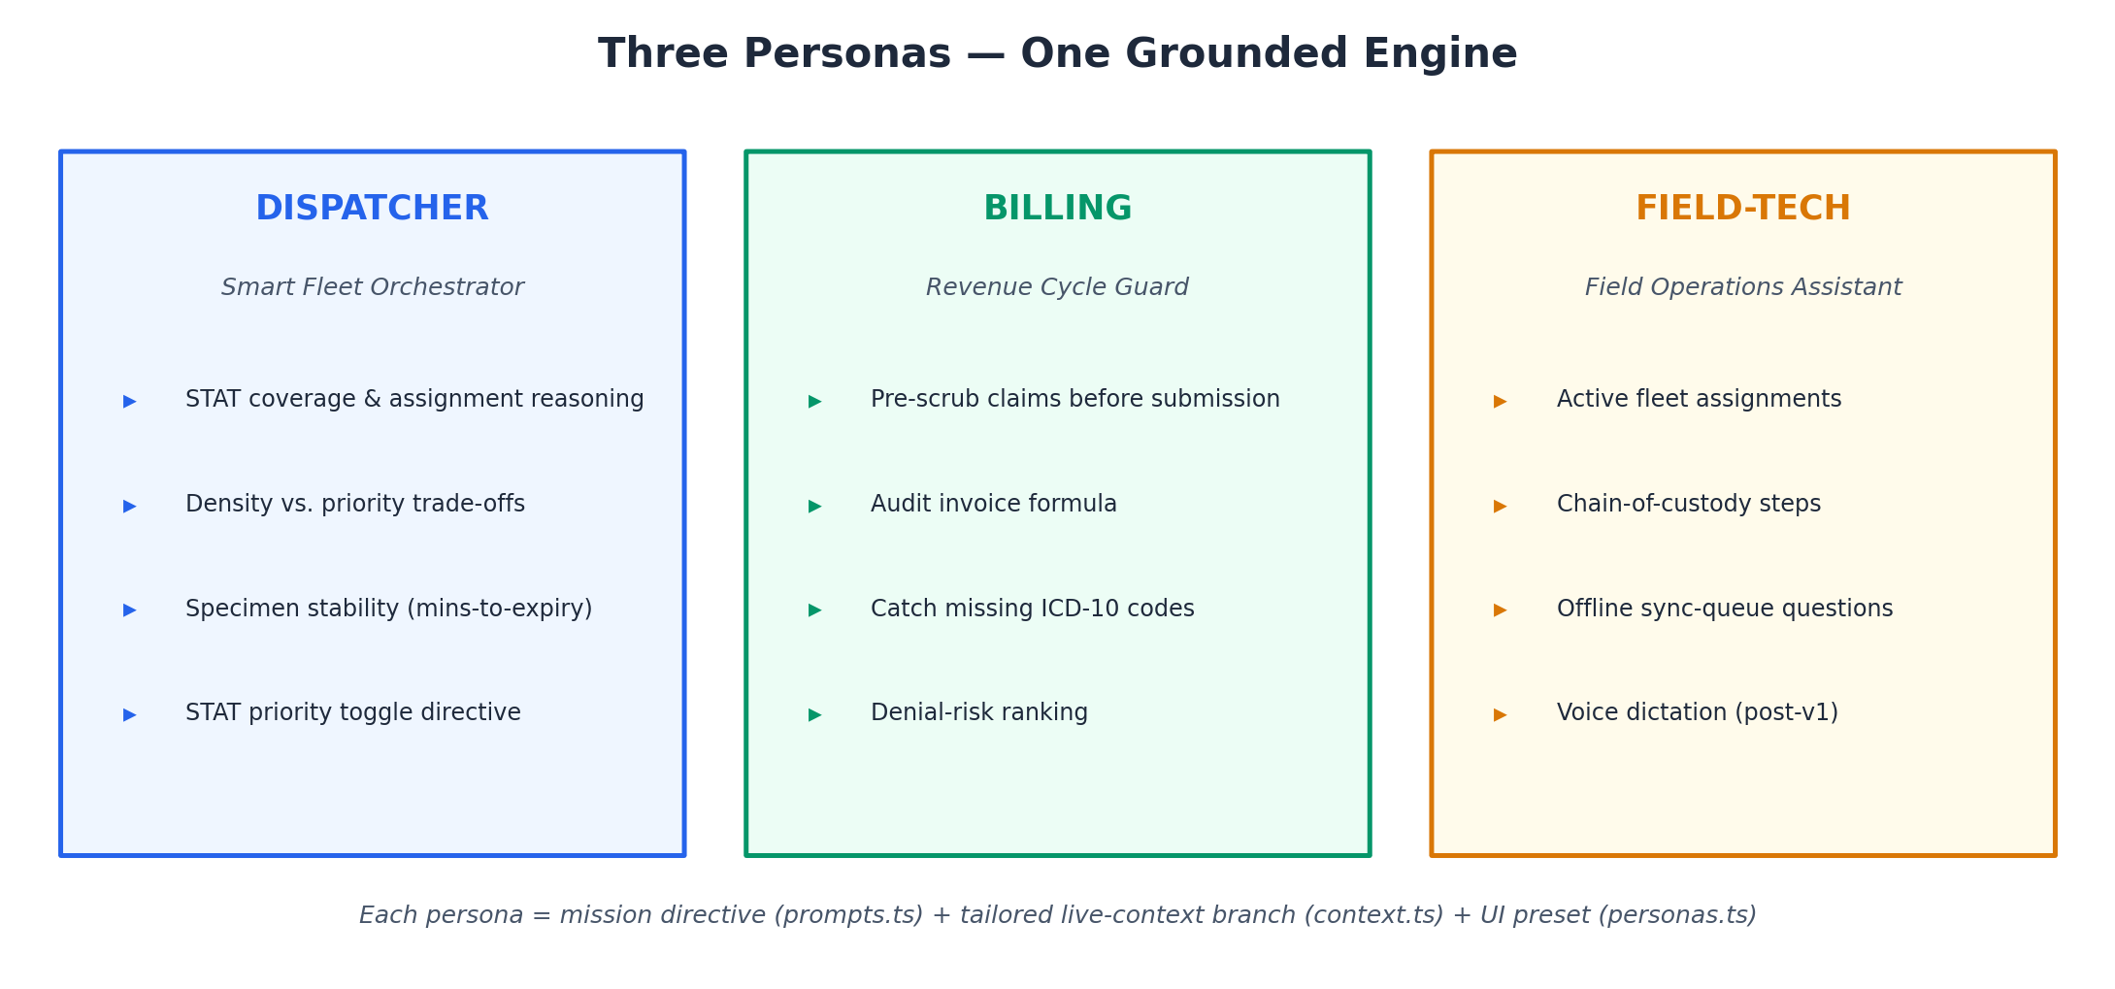
Figure 2 — Persona modules and their operational missions
Persona | Module | Live context injected per request
dispatcher | Smart Fleet Orchestrator | Open STAT orders · specimen stability windows (minutes-to-expiry) · field-staff roster · assignment rules
billing | Revenue Cycle Guard | Flagged invoices · open (unbilled) revenue total · the invoice formula
field-tech | Field Operations Assistant | Active fleet assignments · sync-queue counts · chain-of-custody steps

6. Solution Architecture
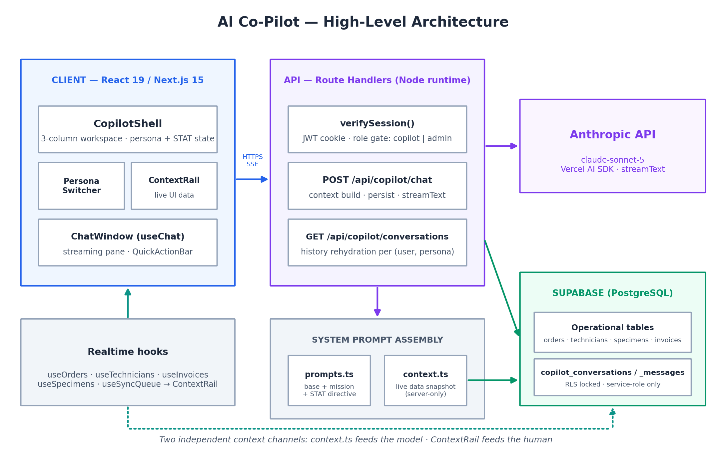
Figure 3 — High-level architecture: client workspace, Node route handlers, prompt assembly, Anthropic API, Supabase

6.1 Technology Stack
Layer | Technology
LLM | Anthropic claude-sonnet-5
AI orchestration | Vercel AI SDK — ai, @ai-sdk/anthropic, @ai-sdk/react
Streaming protocol | AI SDK UI message stream (streamText → toUIMessageStreamResponse ↔ useChat)
Backend | Next.js 15 Route Handlers, runtime = "nodejs" (required by jose and the service-role client)
Auth | Custom JWT cookie (rad-session, jose), role-gated to copilot + admin
Persistence | Supabase (PostgreSQL) via service-role client; RLS-locked tables
Frontend | React 19 client components, Tailwind CSS 3 design tokens
Deployment | Vercel; requires ANTHROPIC_API_KEY

6.2 Defining Design Decisions
Decision | Rationale
Two context channels, never shared | context.ts (text → model) vs ContextRail.tsx (React → human). Keeps the LLM snapshot decoupled from UI rendering; each evolves independently.
Server-side persistence only | User turn saved before the model call; assistant turn in onFinish. Mid-stream reload or browser disconnect never loses data; client carries zero persist logic.
Grounded-only responses | System prompt forbids asserting any specific operational fact absent from injected context, and forbids inventing PHI.
RLS enabled, zero policies | Custom JWT auth means auth.uid() is null; policies would return nothing. All access flows through /api/copilot/* via the service-role client, gated by verifySession().
Graceful mock mode | No Supabase → conversationId null; chat still streams against mock data. Enables demos and local dev without a database.
Real error surfacing | onError returns the actual provider message (e.g. credit balance) so operators and developers see the true failure cause.
Admin bypass | Mirrors proxy.ts — an admin opening /copilot gets a fully working chat.

7. Component Design

7.1 Frontend — Co-Pilot Workspace
The /copilot route renders CopilotShell, a full-screen workspace with its own chrome (no shared Sidebar/NavShell), following the app's role-specific shell precedent (TechnicianShell / ClientShell).
- CopilotShell — owns the two pieces of UI state (persona, statPriority). Three-column responsive layout: persona rail collapses to a bottom tab strip on mobile; the live-context rail drops into a slide-over drawer below the xl breakpoint.
- PersonaSwitcher — dispatcher | billing | field-tech selection; left rail on desktop, bottom tabs on mobile.
- ChatWindow — the streaming engine, built on useChat (@ai-sdk/react). Wires a DefaultChatTransport to /api/copilot/chat, sending { persona, statPriority } in the body. Keyed by conversationId so switching persona cleanly resets and re-seeds the thread. Renders token-by-token, shows a thinking state on submitted, surfaces the real provider error on failure. Holds no persistence logic.
- QuickActionBar — persona preset prompts, the STAT toggle (dispatcher), and a stop-generation control.
- ContextRail — the human-facing context channel. Renders live persona-relevant data from existing realtime hooks (useOrders, useTechnicians, useInvoices, useSpecimens, useSyncQueue), updating independently of the model's snapshot.
- useCopilotConversation — loads the persisted thread for (user, persona) on mount and on every persona switch.

7.2 Backend — Route Handlers
Two Next.js Route Handlers, both runtime = "nodejs", both gated by verifySession() with role copilot or admin (401 otherwise).

POST /api/copilot/chat — the streaming brain
- 1. Verify the JWT session cookie and enforce the role gate (401).
- 2. Check ANTHROPIC_API_KEY is configured (503 if absent).
- 3. Validate messages (array) and persona (one of the three).
- 4. fetchPersonaContext(persona) → build the live operational-data text block from the database.
- 5. Persist the user turn before the model call — a mid-stream page reload never loses the prompt.
- 6. streamText({ model, system: buildSystemPrompt(...), messages }).
- 7. onFinish → persist the assistant turn server-side, even if the browser disconnected mid-stream.
- 8. onError → surface the real provider error instead of a masked generic message.

GET /api/copilot/conversations — history rehydration
Returns { conversationId, messages } for the (user_email, persona) pair. Returns { conversationId: null, messages: [] } when Supabase is unconfigured (mock mode) — chat still streams, just unpersisted.

7.3 System Prompt Assembly (prompts.ts)
Layer | Content
BASE_PROMPT | RAD-OPS identity + anti-hallucination + PHI guardrails
+ PERSONA_MISSION | Per-persona module directive
+ LIVE OPERATIONAL CONTEXT | Text snapshot from context.ts (per-persona branch)
+ STAT_PRIORITY DIRECTIVE | Appended only when the dispatcher STAT toggle is on

8. Data Flow
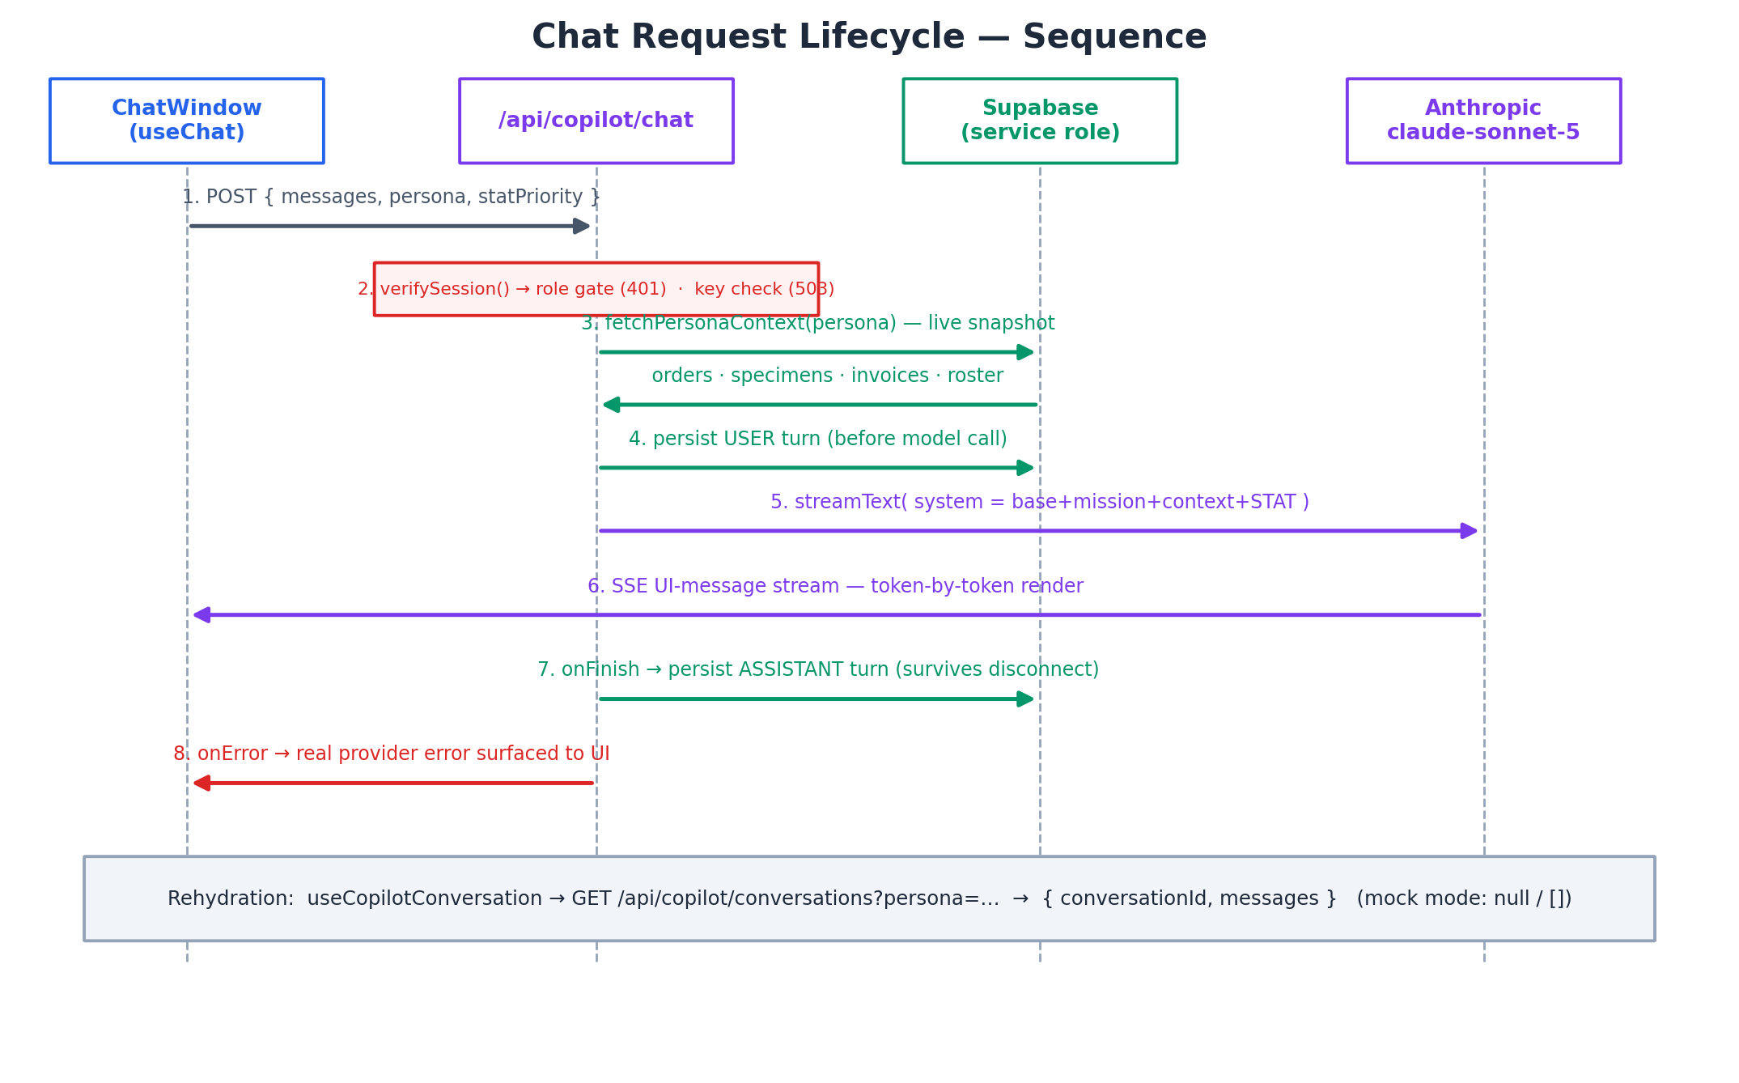
Figure 4 — Chat request lifecycle: auth, context build, persist-before-call, stream, persist-on-finish
Two properties of this flow matter commercially: the user turn is durable before the model is ever called, and the assistant turn is persisted server-side in onFinish even if the browser disconnects. There is no client-side persistence code path at all.

9. Data Design & Persistence
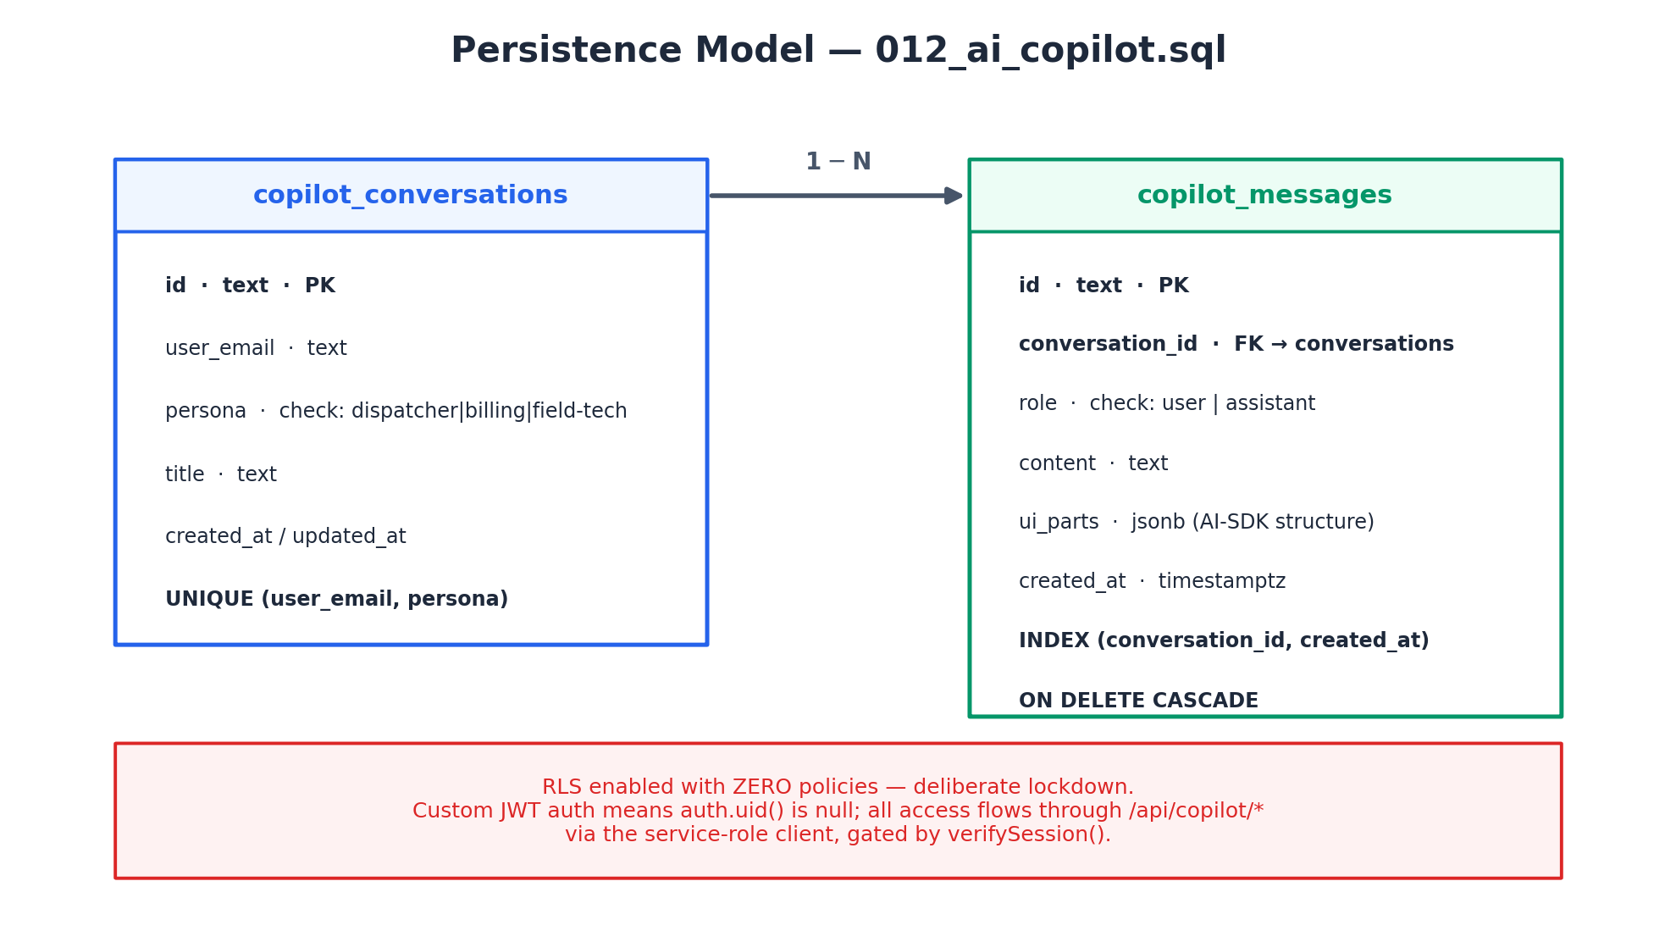
Figure 5 — Persistence model (migration 012_ai_copilot.sql)
- One conversation per (user_email, persona), enforced by a unique constraint.
- getOrCreateConversation is race-safe: a parallel unique-violation triggers a re-read rather than an error.
- ui_parts (jsonb) preserves the rich AI-SDK message structure alongside plain content.
- Cascade delete: removing a conversation removes its messages.
- Read path is indexed on (conversation_id, created_at) for ordered rehydration.

10. Security & Compliance Posture
Control | Implementation
Authentication | Custom JWT session cookie (rad-session) verified with jose on every request; Node runtime required for verification.
Authorization | Role gate: copilot or admin only; 401 otherwise. Admin bypass mirrors the existing proxy.ts pattern.
Data access | RLS enabled with zero policies (deliberate lockdown). All reads/writes flow exclusively through /api/copilot/* using the server-only service-role client.
Secrets | ANTHROPIC_API_KEY and SUPABASE_SERVICE_ROLE_KEY are server-side only; the chat route returns 503 if the model key is absent.
PHI guardrails | System prompt forbids inventing PHI and forbids asserting facts about specific orders/patients/specimens/invoices not present in injected context.
Grounding | Model receives only the compact per-persona snapshot built at request time — no free database access, no tool calling in v1.
Failure honesty | Real provider errors surfaced rather than masked, aiding incident triage.

11. Non-Functional Requirements (NFR Register)
Verification methods: T = test, D = demonstration, I = inspection, A = analysis. Targets marked 'proposed' require SA/stakeholder confirmation.
ID | Requirement | Target | Verify
NFR-001 | First streamed token latency after submit | ≤ 3 s p95 (proposed) | T
NFR-002 | Conversation rehydration on persona switch | ≤ 1.5 s p95 (proposed) | T
NFR-003 | Availability of /api/copilot/* (excl. LLM vendor) | 99.5% monthly (proposed) | A
NFR-004 | Zero message loss on mid-stream disconnect | 100% (user turn pre-persisted; assistant via onFinish) | T
NFR-005 | Responsive layout: mobile bottom tabs, xl slide-over rail | All breakpoints per design | D
NFR-006 | Mock mode: full chat function without Supabase | Streams unpersisted; no errors | T
NFR-007 | Unauthorized access to routes and tables | 401 on role failure; 0 direct-table access paths | T/I
NFR-008 | Provider error transparency | Actual provider message shown, not generic | D

12. Functional Requirements (FRD-Ready Register)
This register is designed to be extracted verbatim into the FRD. Priorities: M = Must, S = Should, C = Could (MoSCoW).
ID | Requirement | Pri | Trace
FR-001 | The system shall expose a Co-Pilot workspace at /copilot rendering a full-screen 3-column layout with its own chrome. | M | §7.1
FR-002 | The system shall provide exactly three personas — dispatcher, billing, field-tech — selectable at any time. | M | §5
FR-003 | Switching persona shall reset the chat thread and load the persisted conversation for (user, persona). | M | §7.1
FR-004 | The system shall stream assistant responses token-by-token with a visible thinking state. | M | §7.1
FR-005 | Each chat request shall inject a live operational context snapshot built at request time for the active persona. | M | §7.3
FR-006 | The dispatcher persona shall offer a STAT priority toggle that appends a STAT directive to the system prompt. | M | §7.3
FR-007 | The system shall refuse to assert operational facts absent from the injected context and shall not invent PHI. | M | §10
FR-008 | The user turn shall be persisted before the model call; the assistant turn shall be persisted in onFinish. | M | §8
FR-009 | The system shall enforce one conversation per (user_email, persona) via a unique constraint with race-safe get-or-create. | M | §9
FR-010 | GET /api/copilot/conversations shall return { conversationId, messages } for rehydration on mount and persona switch. | M | §7.2
FR-011 | Access shall be limited to roles copilot and admin via JWT session verification; all else receives 401. | M | §10
FR-012 | The chat route shall return 503 when ANTHROPIC_API_KEY is not configured. | M | §7.2
FR-013 | When Supabase is unconfigured, chat shall stream against mock data with conversationId null (mock mode). | S | §6.2
FR-014 | Provider errors shall be surfaced to the UI with the actual provider message. | S | §6.2
FR-015 | Each persona shall present preset quick-action prompts and a stop-generation control. | S | §7.1
FR-016 | The ContextRail shall display live persona-relevant operational data updating independently of the chat. | M | §7.1
FR-017 | Messages shall persist rich AI-SDK structure (ui_parts jsonb) alongside plain text content. | S | §9
FR-018 | The persona rail shall collapse to bottom tabs on mobile; the context rail to a slide-over below xl. | S | §7.1
FR-019 | Tool calling (execute actions) — explicitly excluded from v1; extension point only. | C | §4.2
FR-020 | Voice dictation for field-tech (showVoiceMic flag) — post-v1 stretch goal. | C | §4.2

13. Assumptions, Dependencies & Risks

13.1 Assumptions (carry into SOW)
- Client provides Vercel project access and configures ANTHROPIC_API_KEY, NEXT_PUBLIC_SUPABASE_URL, SUPABASE_SERVICE_ROLE_KEY.
- Operational tables (orders, technicians, specimens, invoices) exist with agreed shapes; context.ts reads them, it does not create them.
- The existing JWT auth (rad-session, jose) and proxy.ts role-gating pattern remain the platform standard.
- Anthropic API usage costs are borne by the client; a funded account is available for UAT.

13.2 Risks
Risk | Likelihood | Impact | Mitigation
LLM vendor outage or rate limiting degrades chat | Medium | High | Real error surfacing (already designed); consider retry guidance and status messaging in UI copy
Context snapshot grows beyond effective prompt size as data scales | Medium | Medium | Per-persona compact formatting; add row caps and prioritization rules in context.ts
PHI leakage via transcripts stored in copilot_messages | Low | High | Grounded-only prompt rules; SA/security review of retention and encryption (§17 Q2)
Service-role key misuse if leaked | Low | High | Server-only env var; RLS-zero-policy lockdown means the key is the sole path — protect via Vercel encrypted env
Model output treated as instruction rather than recommendation | Medium | Medium | v1 is read-only by design; tool-calling deferred with explicit human-in-the-loop design gate

14. Delivery Plan & Work Packages (SOW-Ready)
Indicative 12-week plan. Durations assume one full-stack engineer plus part-time SA oversight; calibrate in SOW negotiation.
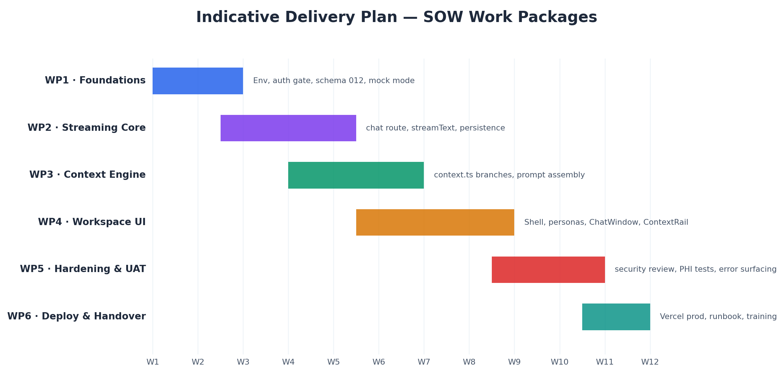
Figure 6 — Indicative delivery timeline across six work packages
WP | Name | Deliverables | Exit criteria
WP1 | Foundations | Env setup, verifySession role gate, migration 012, mock-mode scaffolding | Role gate returns 401/503 correctly; schema applied; mock mode boots
WP2 | Streaming Core | POST /api/copilot/chat with streamText, persist-before-call and onFinish persistence | Token streaming works; disconnect test loses zero messages (NFR-004)
WP3 | Context Engine | context.ts persona branches, prompts.ts assembly, STAT directive | Snapshot per persona verified against DB; STAT toggle changes system prompt
WP4 | Workspace UI | CopilotShell, PersonaSwitcher, ChatWindow, QuickActionBar, ContextRail, rehydration hook | All FR-001…FR-018 demoable across breakpoints
WP5 | Hardening & UAT | Security review, PHI guardrail tests, error-surfacing verification, NFR test evidence | NFR register passed; security callout (§10) resolved
WP6 | Deploy & Handover | Vercel production deploy, runbook, ops training, doc pack | Production smoke test; client sign-off

15. Acceptance Criteria (SOW-Ready)
- All FR-xxx items marked M pass their traced verification in a client-witnessed UAT session.
- NFR-004 disconnect test: kill the browser mid-stream; on reload both user and assistant turns are present.
- Auth test: a non-copilot, non-admin session receives 401 from both routes; direct table access is impossible without the service-role key.
- Grounding test: a question about an order absent from the live context yields an explicit 'not in my data' style response, not a fabricated answer.
- Mock-mode demo: with Supabase env vars removed, the workspace loads and chat streams against mock data.
- Persona-switch test: switching personas swaps mission, context, quick actions, and thread with no cross-contamination.

16. Environments & Configuration
Variable | Required | Purpose
ANTHROPIC_API_KEY | Yes | Model access; chat route returns 503 without it
NEXT_PUBLIC_SUPABASE_URL | Optional | Persistence + live context; absent → mock mode
SUPABASE_SERVICE_ROLE_KEY | Optional* | Server-only service-role client (bypasses RLS); required for persistence
* Required for any persisted environment; optional only for mock-mode demos.

17. Open Questions for Solution Architect Review
# | Question | Owner / needed by
Q1 | Confirm NFR latency and availability targets (currently proposed, not contracted). | SA + client — before SOW signature
Q2 | Transcript retention, encryption-at-rest, and audit-logging requirements for copilot_messages given potential PHI references. | Security lead — WP1
Q3 | Row caps / prioritization strategy for context.ts as operational data volume grows. | SA — WP3
Q4 | Is a per-request token/cost budget or usage dashboard required for the Anthropic spend? | SA + client — WP2
Q5 | Should the SOW include an optional tool-calling discovery phase (extension point) as a priced option? | Pre-sales + SA — SOW drafting
Q6 | Conversation reset/delete UX: v1 has one thread per persona forever — is a 'clear thread' control needed? | Product — WP4

18. Glossary
Term | Definition
STAT | Highest-urgency order class requiring immediate coverage
PHI | Protected Health Information
RLS | Row-Level Security (PostgreSQL/Supabase)
Persona | A specialized Co-Pilot module: mission prompt + context branch + UI preset
Grounded-only | Design rule: the model may only assert operational facts present in the injected live context
Mock mode | Degraded-gracefully state without Supabase: chat streams against mock data, unpersisted
ICD-10 | International Classification of Diseases diagnosis coding standard used in claims
Chain-of-custody | Documented specimen handling steps from collection to lab

